Teacher: Sarbalina Gulbarshyn
The subject: English language
speciality, group: BA-21
The date: 20.12.2016
Тhe theme: “I have a dream…”
The type of the lesson: combined
The aims:
- Educational: to form the speaking skills on the theme “Dream”, including the elements of discussion arguments, to encourage the students to express their point of view using the correct grammar and lexis.
- Developing: To improve students’ vocabulary on the theme, to train their audition and speaking.
- Upbringing: to bring up the students to be able to listen each other and to respect other`s opinions, to bring up the students’ accuracy, responsibility, order, activity and interest in the subject.
The methods: critical thinking, question - answer, group work
The connection with other subjects: self - knowledge, pedagogical proficiency
Visual aids: slides, pictures, interactive board, cards, song, flipchart, video
Procedure of the lesson:
- Organization moment.
Greating, conversation with the duties. (2min)
T. Good morning, children! I’m glad to see you today. How are you? I hope you are fine! Sit down, please! What date is it today? Who is absent?
II. Checking the home task. (5 min)
To tell the rhyme by heart.
III. Warm-up activities (5 min)
T. Look at the screen! Can you guess the theme of the lesson? (DREAMS)
Watching the video film about future dreams.
T. Yes, it’s “dreams”.

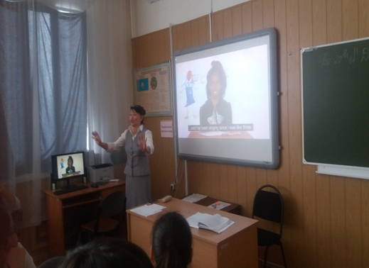
IV. Introductory part. (6min)
T:Tell me, please, what comes to your head when you hear the word dream? Come up to the board and write down your ideas! What is dream? What does it mean in your mind?
Why do people dream?
DREAMS

(to write the words or word combinations which define the word dream)
The answers: It motivates people.
If you can dream it, you can do it.
Dreams are necessary.
Without dreams, there will be no ambition to chase.
It’s a hope, belief, and force.
It helps to achieve the ambitions, goals.
The new words:
1) Dreams-[drɪ:m] арман, түс
2) hope- [həup] үміт
3) ambition [æmˈbɪʃən], goals [gəul] -мақсат
4) to chase- [tʃeɪs]-қудалау, жетегіне еру. (гнаться, следовать)
5) belief [bɪˈli:f] -сенім
6) to achieve [əˈtʃi:v] -жету
7) to motivate [ˈməutɪveɪt] -жігерлендіру, қанаттандыру
8) force [fɔ:s] -күш
9) realizable- [ˈrɪəlaɪzəbl]
10) prosperity [prɔsˈperɪtɪ] -өркендеу
11) wing [wɪŋ] -қанат
T: “Intelligence without dream is like a bird without wings”.
- The main part. Working on the text. (10 мин)
T: Now, look at the screen! Here are some texts and desires, the great dreams of great people. Let’s read them aloud! Now can you guess whose dream is it? The task for you is to match the names to the paragraphs, to find out the owner of each dream. The students must be divided into 4 subgroups.
- The first fighter for the civilian character of African Americans in the United States, minister and activist who was a leader in the African-American Civil Rights Movement and orator. He urged his supporters: should resist racism, but not by force. No bloodshed! He opposed the US colonial aggression and the war in Vietnam. For success in the democratization of American society in 1964, He was awarded the Nobel Peace Prize. He had a dream - to destroy the racial prejudices that white and black could co-exist in the United States as equals.

(Martin Luther King)

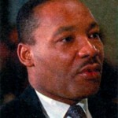
- Another person who changed not only their own lives but also the lives of many people through their dreams -…. Since his childhood, admiring the technique, he has always dreamed of his own invention. A young dreamer left without hesitation every new job, which prevented him to invent and demonstrate their unique ability to design. He was expected to obey and diligently perform monotonous action, but instead of it he founded his own company, and proved to the world that the dream that you wish with all your heart is realizable. (Henry Ford)

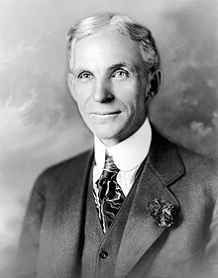
- He had a dream in his youth - to make computers accessible to people. What is the result for today? You bought a computer and to whom some of the money went, do you think? Try to guess it. Besides, who sells Windows, Microsoft, Office & etc. He is one of the richest people in the world. Even you do not pay to him personally, he is paid by the producers of the software on which you are working. (Bill Gates)

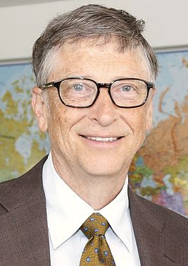
- He had only one desire while his fighting, to win his opponent. He is a professional boxer who currently holds the WBC, middleweight titles. As of July 2016, he is ranked as the world's number one middleweight by The Ring magazine and BoxRec. He was in the Guinness Book as the world champion in the middleweight champion with the highest percentage of knockouts.

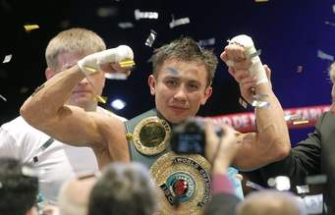
- His dream is to form “the eternal country” with a great future. Its not only his dream but also a national idea and the dream of ancestors.

He has been the country's leader since 1989. He holds the title 'Leader of the Nation'.

He has led the country through difficult times and into an era of prosperity and growth.

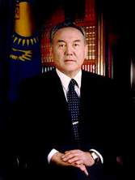

T: Time is up! Let’s compare your answers with the real ones. Look at the screen!

- Relax time. (3 мин)

Dreaming.

Close your eyes and spread your wings,

Make a wish and dream good dreams,

Don’t ever say, you ll never tell,

Cause life is short and very frail.
- Conclusion. The magic Aladdin lamp. (What is your dream?) (10 min)
T. Do you remember the words which were presented at the beginning of the lesson?
T. You see, there are two ways of translating these words.
Let`s revise them.
T: Please write your own dreams using these words and word combinations and put into magic lamp.


F/e: my dream is to travel around the world

learn foreign languages

hopefully move to a sunny and warm place some day

I’d like to explore new cultures, traditions, business and cuisine

to provide poor people with shelter and food with proper education, clothes and water.

I want peace in the world so that no child could be killed and no women could be raped.

I want the earth without pollution.

I wish there will never be war.

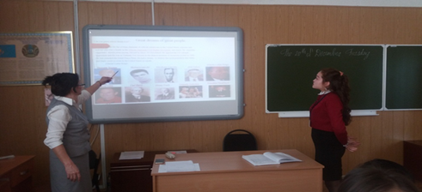

T. I can see you are all dreamers. Now it is time to show them. Dream it. Wish it. Do it.

VIII. Marking. (2 min)
T. Well, thank you for the lesson. And I want to say, that the most hardworking pupils such as
….were excellent today and have “5s”.
….try to be more active. It seems you were a bit lazy today, you can work better. You get “4s” today.
…today you tried hard to work. It’s OK.
IX. Home work. (2 мин)
T. I’d like you to sum up our lesson. As I have already said a short composition about your dreams and wishes will be your home task. Now, I propose you to look at the screen and there are some questions. You can use these questions as a plan to your composition.
T. Is there any necessity to dream?
T. Do you have dreams about your future?
T: What do you do to reach it?
T. The lesson is over now. Good bye!

