The plan of the demonstrative lesson.
The theme: “Enjoy English”
Aims of the lesson:
1. To develop oral speech, critical thinking and attention abilities, to practice group pair work and solutions of problems.
2. To teach students to work creatively and solve different problems
3. . To bring up the feelings of love towards the education.
The type of the lesson: consolidation with the elements of module and critical thinking.
Visual aids: interactive board, slides, posters, colored pictures, proverbs, saying and quotations, printed materials, placates.

The plan of the lesson:
I.Org. moment.
A) Sing a song
II. Expressive reading.Reading a poem.
III. Brainstorming. Answering the questions .
IV. Write the new words using the letters of the word «Acknowledgement.»
V Reading a tangue-twister
VI.Sing a song.
VIII.Judgs marking

The procedure of the lesson:
I. Org. moment
T: Good morning dear guests and pupils. I’m glad to see you at my lesson. You are welcome! Who is on duty today? Who is absent? What date and day is it today? Today we’ll speak about Animals, Food ,House Activities, Clothes, Weather, seasons. There are many guests here and we’ll try to do our best to make this lesson interesting. -Let's start our lesson. The theme of our lesson is "Enjoy English". Today we'll speak English, play interesting games and sing English songs for the whole lesson. Let’s divide into 3 groups. Are you ready?
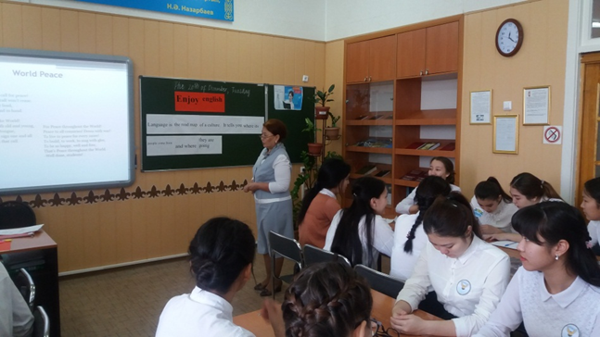

II. Warming up:T: At the beginning of the lesson let’s expressive reading of poems.

About students

Students life is full of fun
work and play.
their day begins with a prayer
And, ends with play.
In school they make many friends,
And learn many trends.
They even learn values
of love and life.

They study all day
And are bright like the sunray
They can even swim
Like the fish on sea-bay.

East or west
Students life is the best,
they can start their day with a prayer
And end with lots of play!

About language

English language is known world wide
From all languages that were collide
English is known everywhere
It is great to use it anywhere

Upholding English to everyone
Speaking in English is very fun
Don't be shy and show your greatness
Use it when showing competitiveness

Speaking in English is as good as gold
The language of English we need to uphold
It's very fun when you come to think of it
When you're with your friends who also loves it

When you go to any country
This is the language of everybody
Being expressed in different place
Different accents on different place

About peace

Peace to the World! We call for peace!
Till Peace prevails, this call won’t cease.
Oh, people, rise in every land,
All fighting bravely, hand in hand.

For Peace throughout the World!
Peace to the World! Both old and young,
Of every land, of every tongue,
They sign their names, sign one and all
Under the clear worlds that call.

For Peace throughout the World!
Peace to all countries! Down with war!
To live in peace for every more!
To build, to work, to sing with glee,
To be so happy, well and free,
That’s Peace throughout the World.
-Well done, students!

III. Brainstorming. Answering the questions on the box to different theme. .T -Well, look at the active board, there are many boxes and themes.
- Animals
- Food
- House
- Activities
- Clothes
6..Weather, seasons
-Choose one theme and box, then do exercises. Good luck!

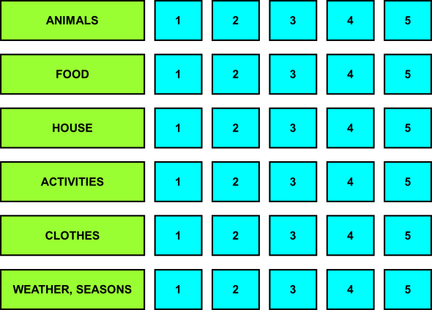

-Well done, students!

IV. Write the new words using the letters of the word «Acknowledgement.»
T-Come up with as many new words as possible using the letters of the word:

«Acknowledgement»

V. Reading a tongue - twister: You will read it for munits. your time is 1 min.
Tongue twisters are a great way to practice and improve pronunciation and fluency. They can also help to improve accents by using alliteration, which is the repetition of one sound. They’re not just for kids, but are also used by actors, politicians, and public speakers who want to sound clear when speaking. Below, you will find some of the most popular English tongue twisters. Say them as quickly as you can. If you can master them, you will be a much more confident speaker.

1. Peter Piper picked a peck of pickled peppers
A peck of pickled peppers Peter Piper picked
If Peter Piper picked a peck of pickled peppers
Where’s the peck of pickled peppers Peter Piper picked?

2. Betty Botter bought some butter
But she said the butter’s bitter
If I put it in my batter, it will make my batter bitter
But a bit of better butter will make my batter better
So ‘twas better Betty Botter bought a bit of better butter

3. How much wood would a woodchuck chuck if a woodchuck could chuck wood?
He would chuck, he would, as much as he could, and chuck as much wood
As a woodchuck would if a woodchuck could chuck wood

VІ. Song

Let’s sing a song about friendship.

-You have worked very well today. Thank you very much, students. How are you feeling at the English lesson today? S1; S2; S3.

VІI. Judges’ marking

IV.Riddles

-Let’s solve the «Riddles»

First group

1.I`m little and green.
I can hop and swim, and sing.
I live in the lake. (a frog)

2. I`m brown and big.
I like honey. (a bear)

3. I`m little and grey.
I like cheese very much.
I live under the house. (a mouse)
Second group
4. I am big and I am strong,
And my trunk is very long!
(an elephant)
5. It is blue
And green, and red,
It bounces higher
Than my head,
It does not want
To stop at all.
What is it?
It is my… (ball)

6.Сlean, but not water,
White, but not snow,
Sweet, but not ice-cream,
What is it? (sugar)

Third group
7. What is found over your head but under your hat? (your hair)

8. I am purple, yellow, red, and green
The King cannot reach me and neither can the Queen.
I show my colours after the rain
And only when the sun comes out again (a rainbow)

9. Look at my face and you see somebody
Look at my back and you see nobody. (a mirror)

V. Song

Let’s sing a song about friendship.

-You have worked very well today. Thank you very much, students. How are you feeling at the English lesson today?

VI. Judges’ marking

IV.Riddles

-Let’s solve the «Riddles»

First group

1.I`m little and green.
I can hop and swim, and sing.
I live in the lake. (a frog)

2. I`m brown and big.
I like honey. (a bear)

3. I`m little and grey.
I like cheese very much.
I live under the house. (a mouse)
Second group
4. I am big and I am strong,
And my trunk is very long!
(an elephant)
5. It is blue
And green, and red,
It bounces higher
Than my head,
It does not want
To stop at all.
What is it?
It is my… (ball)

6.Сlean, but not water,
White, but not snow,
Sweet, but not ice-cream,
What is it? (sugar)

Third group
7. What is found over your head but under your hat? (your hair)

8. I am purple, yellow, red, and green
The King cannot reach me and neither can the Queen.
I show my colours after the rain
And only when the sun comes out again (a rainbow)

9. Look at my face and you see somebody
Look at my back and you see nobody. (a mirror)

